Welcome to our office.

Please scan the QR code below to begin your visit today.

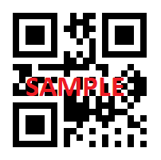

Download the ECLIPSE Check-In App from either the Apple or Google stores directly to your cellphone using the QR code below:
